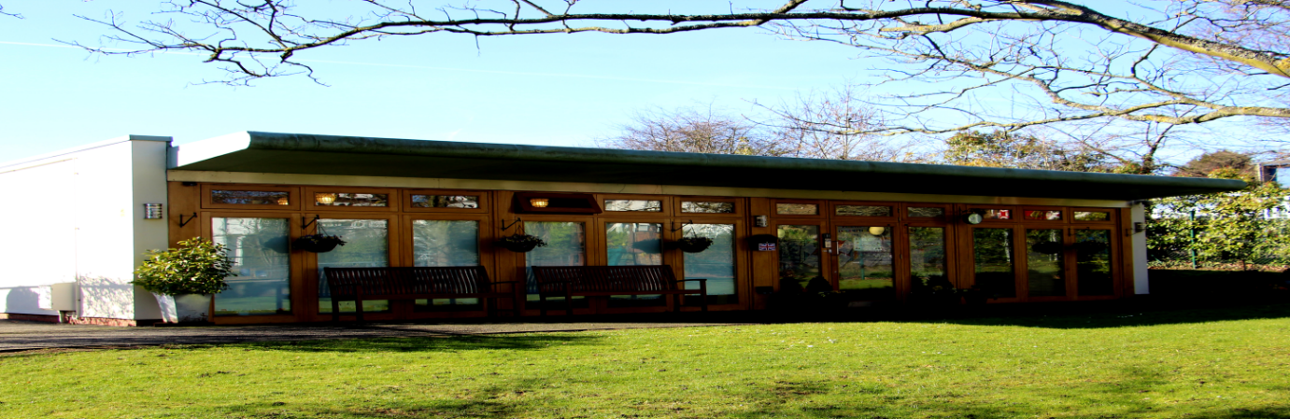

The Revised Early Years Foundation Stage (EYFS)
What parents/carers need to know
What is the EYFS?
The Early Years Foundation Stage (EYFS) was originally launched in 2008. It is the statutory framework for all early years providers in England but it is held in high regard worldwide. The Statutory Framework for the Early Years Foundation Stage sets the standards that all early years providers must meet. Early years providers in England who provide care and learning for children from birth to the end of reception class must comply with the EYFS Statutory Framework. Ofsted regulate and inspect all early years providers against the safeguarding and welfare requirements and areas of learning to determine how well children are kept safe and healthy.
This is a very important stage as it helps your child get ready for school as well as preparing them for their future learning and successes. From when you child is born up until the age of 5, their early years experience should be happy, active, exciting, fun and secure, and support their development, care and learning needs.
From time to time the EYFS is updated and refreshed, so far this has happened in 2012, 2014 and 2017.

What is changing?
From September 2021 a revised EYFS will come into force. The key messages about the reforms include:
- Reducing practitioner/teacher workload and needless paperwork to allow for more quality time and interactions with the children
- Improving the outcomes of all children and addressing/reducing the disadvantage gaps
- The importance of workforce knowledge and professional development to inform assessments. Reflect upon the need to assess every child’s development against ‘check lists’, saving formal steps of assessment for when they are necessary
- Making early learning goals clearer and more aligned to Y1 curriculum.
What do the changes mean to me as a parent/carer?
The safety of your child and the quality of the education provided will not change. You may not see any changes in terms of the activities and opportunities on offer to your child/ren. However, you may notice that we are not physically recording as many observations and assessments of progress. Please be reassured that we will still be supporting your child’s development and responding to their interests. We will be using our professional judgements to assess your child’s development during our daily interactions and activities. The progress check at 2 years is still a mandatory assessment point and we will still share your child’s development and progress with you.
Please feel free to contact the Managers at any time to discuss your child’s progress or if you have any concerns.
Please feel free to look at our Village Nurseries website www.villagenurseires.org
We are also on Instagram village.nurseries where we share lots of wonderful pictures of activities/experiences

Our pedagogy
Our intent is to ensure every child reaches their full potential and our motto is for the children to be happy and safe whilst learning through play. We provide a mixture of adult and child led activities inside and outside. We provide small group activities and ‘wow’ focus activities/experiences throughout the day for all our children based on their needs and/or interests that the key person has planned. We also provide some in the moment planning for example if a child was trying to use the scooter, we would show them how and encourage them to practise this skill. We nurture, model and teach the children through play.
Our pedagogy also covers:
- Development and focuses on how and why children change in terms of their learning and development over time.
- Behaviour and how a child’s experiences shape their behaviour.
- Relationships and how children change and learn in relation to those around them.
- Culture and how family life and culture
- Critique inviting us to challenge assumptions and issues around power, equality and curriculum expectations
We are passionate about helping our children and are excellent role models for our children helping every child to reach their full potential.

Our curriculum
The 7 areas of learning and development within the EYFS have not changed, these are:
• Communication and language
• Physical development
• Personal, social and emotional development
• Literacy
• Mathematics
• Understanding the world
• Expressive arts and design
The prime areas of learning form the essential foundations for healthy development and future learning. Once a solid start has formed within the prime areas we continue to build upon these skills, opening to explore more learning opportunities within the specific areas of learning. “It is crucial for children to develop a life-long love of reading – EYFS 2021”.
These 7 areas are the basis for our curriculum. Careful thought is given to inform our enabling environments (indoors and outdoors), to provide resources, activities and learning opportunities to meet each child’s unique requirements. Ofsted call this ‘curriculum’. Our curriculum is very flexible and responsive to follow children’s interests and those totally unplanned learning opportunities that sometimes come out of the blue, such as it unexpectedly snowing, watching the wildlife in our magical secret garden etc!

Young children learn through play. Play is central to children’s lives. It is the way they make sense of the world around them and the circumstances they find themselves living through.

The EYFS refers to the Characteristics of Effective Learning.
These are:
• Playing and exploring
• Active learning
• Creating and thinking critically

Every EYFS provider has their own bespoke curriculum, to support each child’s unique developmental pathway, following their interests and fascinations.
We use the ‘Development Matters’ which is non-statutory curriculum guidance. The seven key features of effective practice are:
- The best for every child
- High quality care
- The curriculum: what we want children to learn
- Pedagogy: helping children to learn
- Assessment: checking what children have learnt
- Self-regulation and executive function
- Partnership with parents
The age bands have been simplified to avoid tracking activities that do not support child development. They are now birth to 3, 3 and 4 year olds and children in reception.
We work in partnership with our parents/carers and we email our parents/carers information etc as well as displaying information in our foyer, on the windows/display boards and giving hard copies
At Village Nurseries we ensure every child has the cultural capital they need and work with our families/carers to gather knowledge about the child’s home life, their wider family, where they live eg if they have garden, their background, their cultures, festivals or celebrations they celebrate, any pets they have, hobbies etc. We can plan for the kinds of experiences that we can give them for example visiting our local Library and park.
You can find out about the quality of your child’s nursery and other early years providers in relation to the EYFS framework by checking what the Government’s official inspection body for early years, Ofsted has to say about it. To find this information please look at our last Ofsted reports
www.ofsted.gov.uk/inspection-reports/find-inspection-report

